Critical Thinking:

1. [N/A]
2. Integer[20] quantities = {1, 2, 3, 4, 5, 6, 7, 8, 9, 10, 11, 12, 13, 14, 15, 16, 17, 18, 19, 20};
3. Double[] heights = {1.65, 2,15, 4,95};
4. For(Integer grades : grades){

System.out.println(grades);

}

* 1. 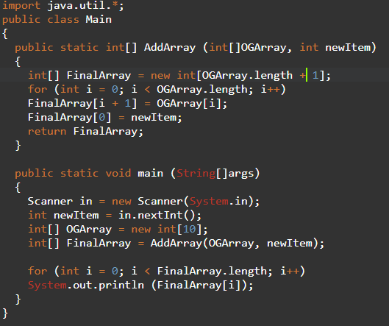
  2. 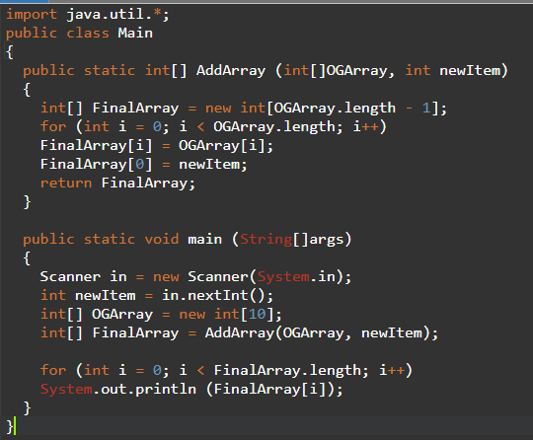

1. Passing a single element only gives the value of that element, and does not allow it to be changed.
2. When a range should be shifted to correlate to a smaller range of index values.
3. It will print ‘I’
4. 1. For arrays its Arrayname[Index]; for arraylists its Arrayname.get(index);
   2. You cant add elements only rewrite in arrays. For arraylists its Arrayname.add(whatever);
   3. You cant delete elements from arrays only rewrite, for arraylists its Arrayname.remove(index);
   4. Use Arrayname.length for arrays and Arrayname.size() for arraylist
5. When you do not know the final size of the data.
6. Returns the index of the first matching element